G4 GUIDANCE

Submitted to:

Ma’am Amna Mirza

Submitted by:

Group NO.6

Subject:

Object Oriented Analysis and Design



**Deliverable NO.1**

**VISION:**

“Our vision is to provide a platform for inter students of Pakistan to help them choose university wisely according to their marks.”

***Explanation:***

* Our primary purpose is to facilitate the inter students of Pakistan by providing them proper guidance about their career and help them choose their field and institution.
* Through G 4 Guidance, students will be able to easily calculate their aggregate for different universities by just entering their marks. And our site will estimate according to last year merit and will filter out all the universities where the students can apply.
* Through this platform, students will be able to get proper career counseling by watching the playlist of top career counselors provided on the site.

**Requirement Gathering:**

* There will be a menu to navigate to different pages of site.
* User will be able to sign up / login through respective buttons.
* ***Homepage*** 
  + Call to action slideshow which contains primary information of website.
  + Top universities list.
  + A button to redirect user to “Find Universities” page.
  + Best Blogs for career counseling.
  + Video for counseling and short description side-by-side.
  + Payment Plans.
  + “About Us” section with social media icons.
* ***Find Universities***
  + Students will be asked about their field of study i.e., Pre-Medical, Pre-Engineering.
  + Students will be asked about their Matric and Intermediate marks.
  + Students will be asked about which entrance test they have taken from a provided list.
  + Students will be asked to enter their marks for each entrance test they have selected from the list.
  + There will be a calculate button that will store the information provided by student in database.
  + After that, count of universities (where student can apply) will be displayed.
  + Then, student will be redirected to the checkout page if he has not purchased any package before.
  + Else, the list of universities according to the purchased package will be displayed with their last year merits and the student’s aggregate according to respective university.
* ***Blog***
  + All the Blogs will be available at this page.
  + Blogs can be filtered through their categories.
  + Only 9 Blogs should be visible at a first in the form of 3 rows and 3 columns.
  + There will be a button that’ll load three more Blogs when clicked.
* ***Playlist***
  + All the Videos will be available at this page.
  + Videos can be filtered through their categories.
  + Only 9 Videos should be visible at a first in the form of 3 rows and 3 columns.
  + There will be a button that’ll load three more Videos when clicked.
* ***Checkout***
  + This page First prompts the user to Login / Sign Up if user is not already logged in or Signed Up.
  + It’ll gather all the information about Credit Card.
  + It’ll gather all the personal and postal information about user.
  + There’ll be a confirm payment button that will store all the payment information in database.
  + Then, it’ll authenticate the card by sending OTP or Some other means.
  + After authentication required amount will be deducted from card and status of user will be updated in database from visitor to Customer with Package type.
  + Then it’ll again redirect to that page from where checkout page is called.
* ***Single Post Page***
  + This page will show the Title of each blog post dynamically.
  + Then it’ll show the other information about post like Author name, Date of Publish
  + After that it’ll show the complete post.
  + After blog post There is an option to share the post over Social Media platforms.
  + At the end there’ll be an Email Subscription Form.
* There will be a footer that will contain quick links and Copyright Information.
* ***Admin Panel***
  + There will be proper a set of tools for document formatting for Author where he can write, edit or publish posts.
  + It will contain options like Bold, Italic, Underline, Insert etc.
  + There will be list of all the blogs from where author can add, delete or update a blog post.
  + There will be a list of all Universities from where admin can add new universities, updated them or delete some University.
  + To Perform CURD operation there will be a form that will first ask for university name, then about its departments and last year merit for each department and lastly the link of University site.
* ***Media Player*** 
  + There will be a media player of site to play videos
  + I have functionalities like Play, Pause, Sound, Video Process Slider and full screen functionalities.

**FURPS**

**Functional:**

***Features:***

* + User can create account using Sign up or Login to an existing account.
  + User Can Fill a form where he/she will enter his/her academic records.
  + Aggregate will be calculated and a list of universities will be generated accordingly.
  + User have to buy a package to view the list of universities where he can apply.
  + User will have to pay using Card according to the package he wants to buy.
  + User have to fill his card details checkout page to pay for package.
  + User will be provided a list of Blogs and Videos, which he can visit, play or read.
  + There will be a site media player to play the video, it will contain Play, Pause, Sound, Video Process Slider and full screen options.
  + User can fill Subscription form to get every update about over website.
  + Author will have a proper editor to Edit or Create posts.
  + Admin will have a university form from where he can add, delete or updated Universities.

***Security:***

* + While creating the account User have to verify his email address, through a mail sent to the Email provided.
  + User have to submit human verification captcha every time he/she fill any form to avoid bot attack on site.
  + User have to enter OTP sent to his/her mobile phone to verify his card payment.

**Usability:**

***User Factor:***

* There will a menu in header and quick links in footer from where usercan easily navigate to any page of website.
* While filling the form there will an information icon on the right side of each input field that describes, how to enter data in that input field or what type of data can be entered in that field.
* If there is a compulsory input field, there will be a visible red star with the name of that field.
* If a User try to submit a form without filling some compulsory input field, that field will be filled with light red color and user will be moved to that part of form where that field exists.
* Proper and Uniform font size will be used in entire that can easily be readable specially in case of blog posts.
* No color associated with color blindness will be used.

***Admin Factor:***

* + List of Blogs and Universities can be sorted in ascending or descending order according to date, these can also be sorted in alphabetical order.
  + In post editor author can also use commands like “Ctrl + B” to Bold a word for “Ctrl + I” to make a word italic.
  + While filling the form there will an information icon on the right side of each input field that describes, how to enter data in that input field or what type of data can be entered in that field.
  + If there is a compulsory input field, there will be a visible red star with the name of that field.
  + If a User try to submit a form without filling some compulsory input field, that field will be filled with light red color and user will be moved to that part of form where that field exists.

**Reliability:**

* + **Failure:** As there are hundreds of universities and a large number and departments so there might be a chance that our site may not show the data if the data to be shown to user is large and browser timeout occurs.

**Recoverability:** In that case user can reload the website and system will show the him university data list without asking him to refill the form.

* + **Failure:** There might be chance that user try to buy a package but due to poor internet connection charges are deducted from user account and no package was allocated to the user.

**Recoverability:** In that case system will compare the user data and bank transaction if there’s a transaction with respect to that account and no package was allocated then system will return the amount to the user.

**Performance:**

* + As we are using C# as backend language and JavaScript so over site’s compile time and runtime will be very well.
  + As we are using Azure Database services so whatever the size of data to be fetched it will fetch it in the matter of seconds.
  + As we are using Azure Hosting so our site response time will be very well and user will not have to wait for a long time.
  + We have a slideshow at the top of our homepage that will keep on changing the slides and some other transitions, these features will reduce the speed of our site a little bit.
  + There’s a rare chance that large number of users use our website at a time, so there’s very much less chances that our site slows down due to large traffic.
  + If a user’s universities list is large then there’s a chance that our site will perform a bit slower.
  + As it’s an online platform/website so anyone can access it 24/7.
  + It’ll always provide an accurate calculated aggregate but it provides list of universities on estimation base.

**Supportability:**

***Adaptability:***

* If we want to increase the packages rate our system can easily adopt it.
* If aggregate calculation criteria for any university changes our system can easily adopt it.
* If the Government Law changes about tax deduction, we can easily adopt it in our website.

***Maintainability:***

* If technology updates like if some new type of database is introduced that will work better as compared to existing one, then we can easily replace it with existing one.
* If we want to add some new feature in our site, we can easily add that feature without disturbing any previous one.

***Internationalization:***

* + We can make our website international by adding Universities of other countries.
  + We are also required to add international law of payment.

**Supplementary Specifications (+):**

***Implementation Constrains:***

We are required to make a Web based application that is based on HTML, CSS and JS for Front-End and C# for Back-End. Also we are required to use Azure SQL Server for Database.

***Purchase Components:***

* We need to buy a domain name for our website.
* We need to buy a Hosting Platform for our website.
* We need to buy an Azure SQL Server for Database.

***Free Resources:***

We may use some free open-source resources or libraries from GitHub in the Development of Front-End and Back-End.

***Software Interfaces:***

We need payment authorization by the respective card company, we are required to plug the interface of the authorization window of respective card company in our website.

***Legal Issues:***

* If we are using some licensed source, we are required to get permission or to buy it before using it in website.
* For online payment we are required to follow the laws of tax declared by government.

***Licensing:***

* We are Required to register the copyrights of our website.
* As Tax is deducted on payment, we are required to register our website in government tax collection institute i.e., FBR

**Feature List:**

* Account Management
  + - Login
    - Sign Up
* Find University
  + - Get Marks
    - Calculate Aggregate
    - Generate List of Universities
* Blog Post Management
  + - Publish a Post
    - Add a post to featured posts
    - Update a Post
    - Delete a Post
* University Merit Records Management
  + - Add New University to the Database
    - Update Merit of Each university every year
    - Delete University
* Payment Management
  + - Card information
    - Postal Information
    - Payment Authorization
    - Updating the User Database
* Generate Single Post Preview
  + - Get Post Data from Database
    - Assignment Data to Template
  + Media Player
    - Play/Pause
    - Sound
    - Video Progress Bar

**Domain Rules:**

* Only those users can get University list according to their marks that have bought some package.
* Username and email of two users cannot be same.
* Password will be of at least 8 characters containing at least one capital Alphabet (Not first one), at least one number and at least one special character.
* Those Who have bought a package of $5/month can see a list of 5 Universities according to their marks.
* Those Who have bought a package of $10/month can see a list of 10 Universities according to their marks.
* Those Who have bought a package of $20/month can see a list of all Universities according to their marks.
* Tax of 0.3% will be charged for Filer and for Non-Filer 0.4% tax will be charged.
* Those who have filled the subscription form get the update mail about every new blog or video posted on site.

**Risk list:**

* As site database contain data of hundreds of universities and thousands of departments so the result generation process might be slow.
* As we have online payment process so there might be a chance that some packet sniffer gets the card information of some user.
* There's a chance that some bot starts filling the Find University form/subscription form/Login form/Sign-up form again and eventually our site slows down and then collapse.

**Feasibility:**

***Are we Technically Feasible?***

Yes, as we are required to build this website using HTML, CSS, JavaScript and C# and we have skill set for these Languages so we are technically feasible with this project.

***Are we Operationally Feasible?***

Yes, as we can easily calculate aggregate for every university using their formula hence we can also implement it in our site, also we can add features of Blog posts, Playlist and Payment easily. Also its users and managers are going to have good experience with it so we are Operationally Feasible with it.

***Are we Economically Feasible?***

Yes, our stakeholders have enough budget for this project so we are economically Feasible with it.

***Are we Feasible with Time?***

Yes, we have 4 months to complete this project so we are also Feasible with Time.

**Actors**

**Primary Actors:** Student, Admin

**Secondary Actors:** Email verification system, Tax calculator, Bank

**Off-stage Actors:** Payment authorization system

**Goals**

*Visitor:*

* + He creates account and verifies through mail.
  + He login to his account if he already has.
  + He sees the top universities list.
  + He reads blog(s).
  + He watches career counseling video(s).
  + He fills the subscription form.
  + He enters his academic records and clicks on “Calculate aggregate” button.
  + If he has already purchased a package, he is then shown a list of universities along with his aggregate for each university. Else he is shown a count of universities and is then directed to checkout page.
  + He sees the payment plans.
  + He selects a package to purchase it.
  + He is then directed to a form where he enters his card details, personal info etc.
  + He submits the form and successfully purchases the package.

*Admin:*

* + - He creates a new post.
    - He updates a new post.
    - He deletes a post.
    - He publishes a post.
    - He adds a post to featured posts.
    - He adds a New University to the Database.
    - He updates Merit of Each university every year.
    - He Deletes a university.

**Use Cases**

* Menu
* Create account
* Login
* Enter academic records
* Calculate aggregate
* Generate list of universities
* Create Blog post
* Blog Post Management
* Manage University Records
* Purchase a Package
* Media Player
* Single Post Preview
* Fill subscription form

**Casual Description of Use Cases:**

**1- Create account:**

***Main success scenario:***

The visitor creates his account by entering the required information.

***Alternative scenarios:***

* If the visitor enters wrong information e.g., wrong format of any required info, he will be notified about it and will have to enter the info again to successfully sign up.
* If the visitor enters wrong Gmail account, he will be notified about it and will have to enter his account again to successfully sign up.
* If the visitor already has an account on our site, he will be notified that he cannot create a new account and his sign up will be failed.
* If the system detects failure in communicating with the external system to verify the Gmail account of visitor, the visitor will be asked to try again.

**2- Calculate aggregate:**

***Main success scenario:***

The visitor enters his academic records and required info without any mistakes and successfully generates a list of universities along with his aggregates for each of them.

***Alternative scenarios:***

* If the user does not fill the “matric marks” field correctly, he will be notified to correct his mistake to generate the list successfully.
* If the user does not fill the “intermediate marks” field correctly, he will be notified to correct his mistake to generate the list successfully.
* If the user does not fill the “entrance test marks” field correctly, he will be notified to correct his mistake to generate the list successfully.
* If the user leaves any required field empty, he will be notified to fill that field to generate the list successfully.

**3- Purchase a Package:**

***Main success scenario:***

The visitor enters his card details, personal info and all other required info correctly, submits the form

without any mistakes and successfully purchases the package.

***Alternative scenarios:***

* If the user does not fill the card details correctly, he will be notified to correct his mistake to successfully purchase the package.
* If the user does not fill the personal info correctly, he will be notified to correct his mistake to successfully purchase the package.
* If the user does not fill any required info correctly, he will be notified to correct his mistake to successfully purchase the package.
* If the user leaves any required field empty, he will be notified to fill that field to successfully purchase the package.

**Package Diagram**

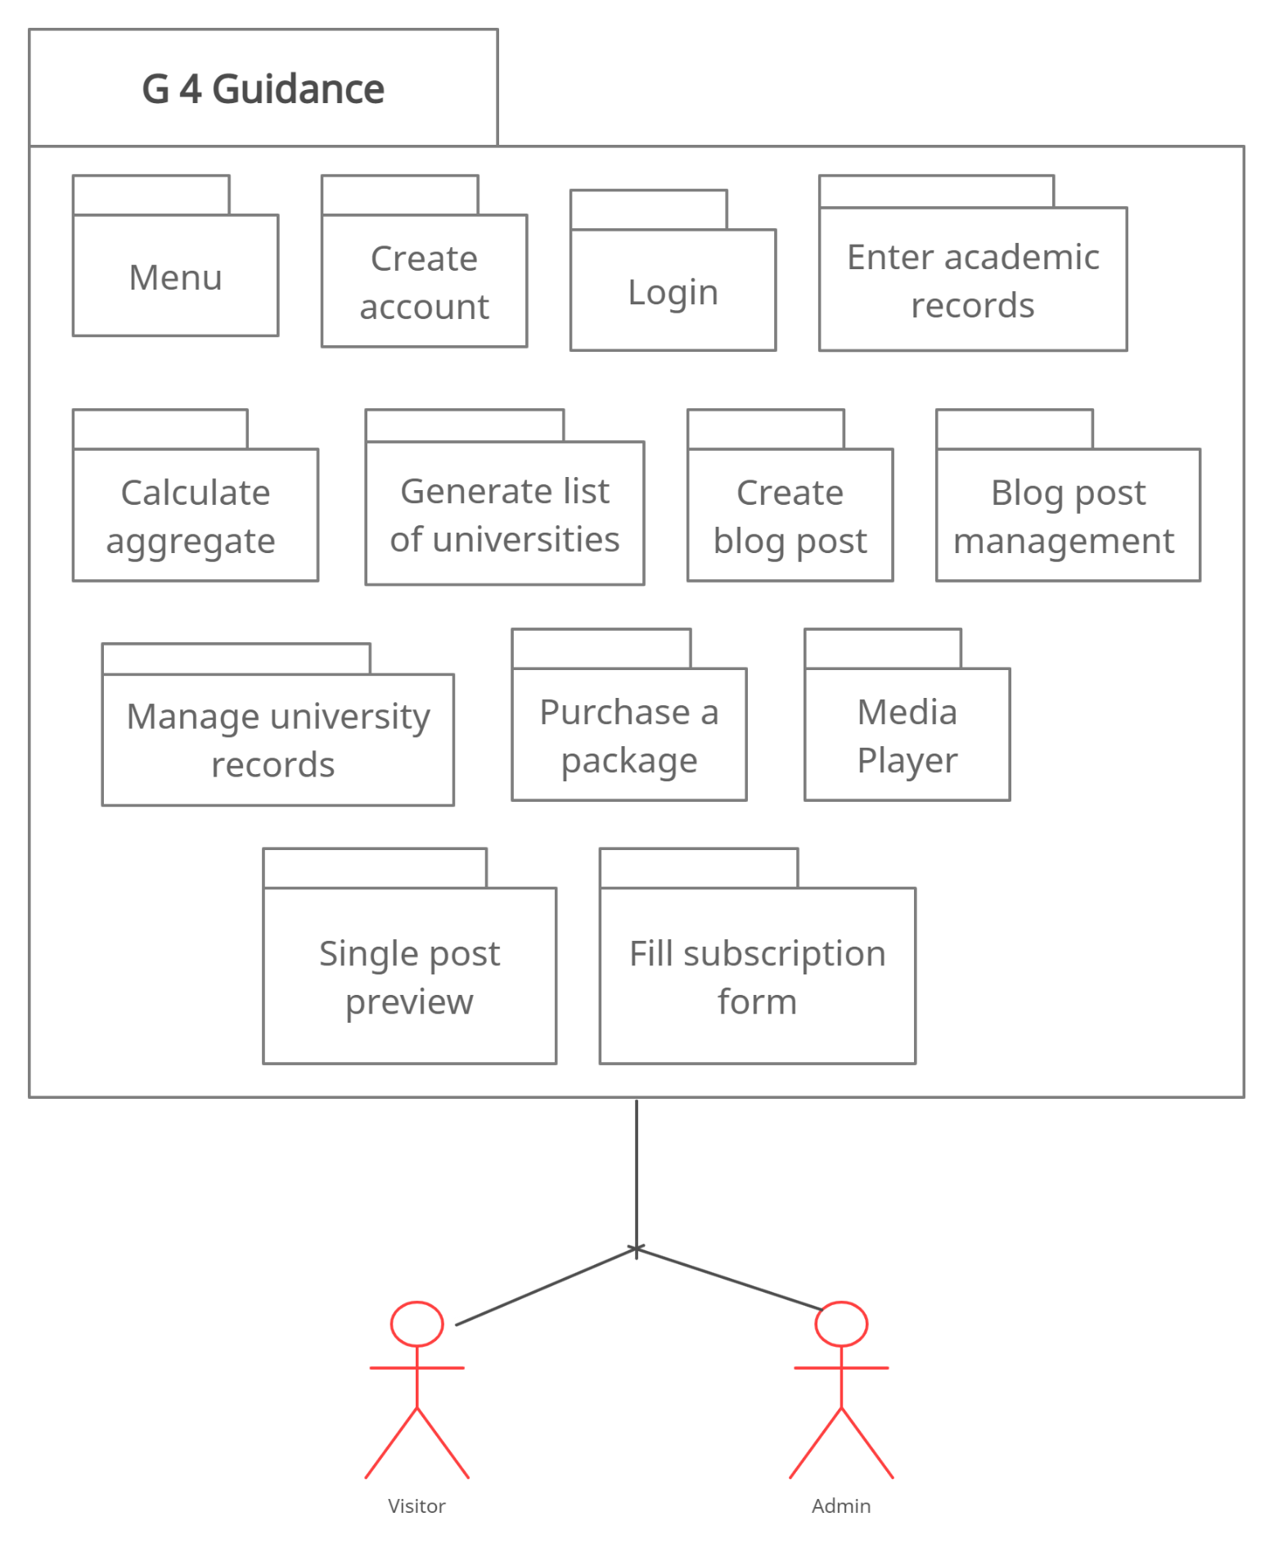

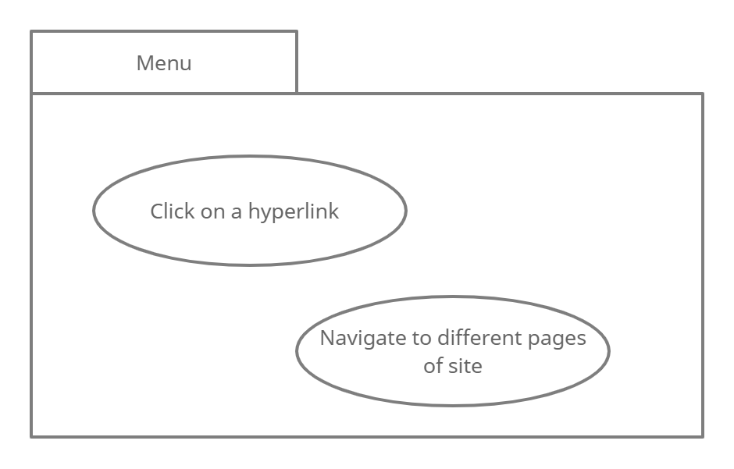

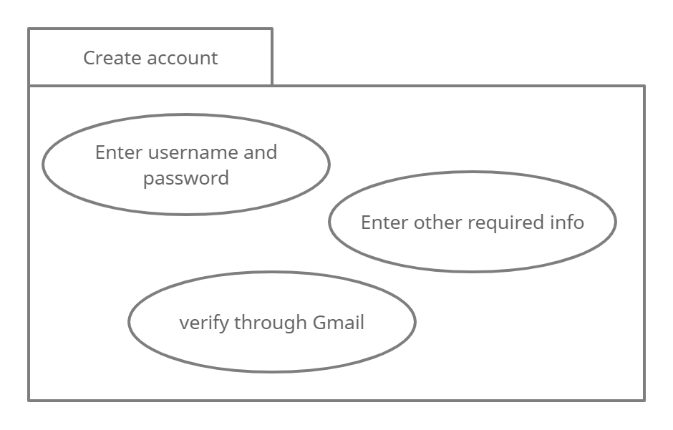

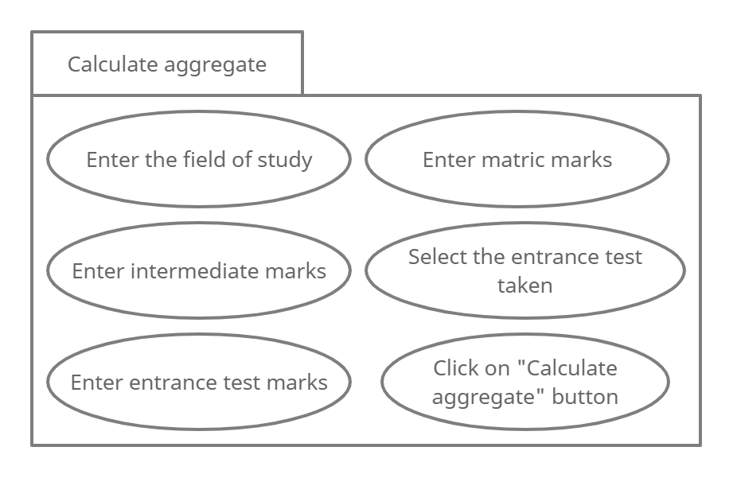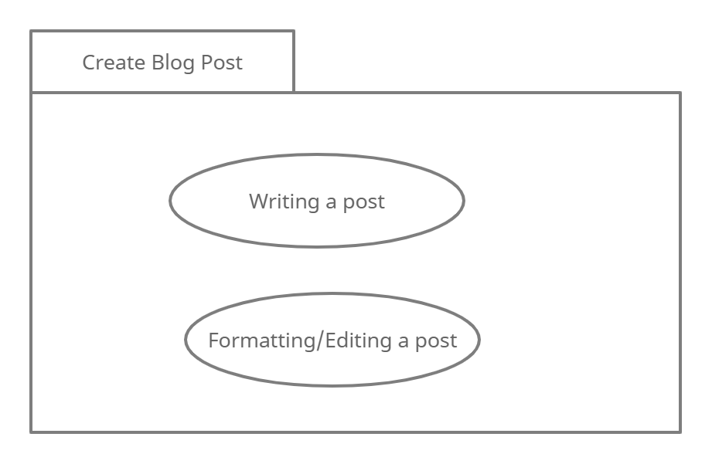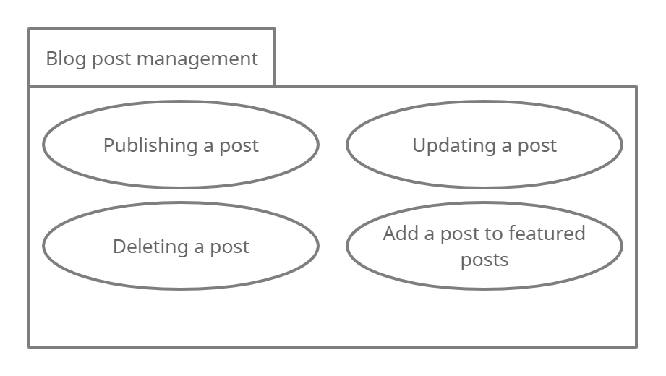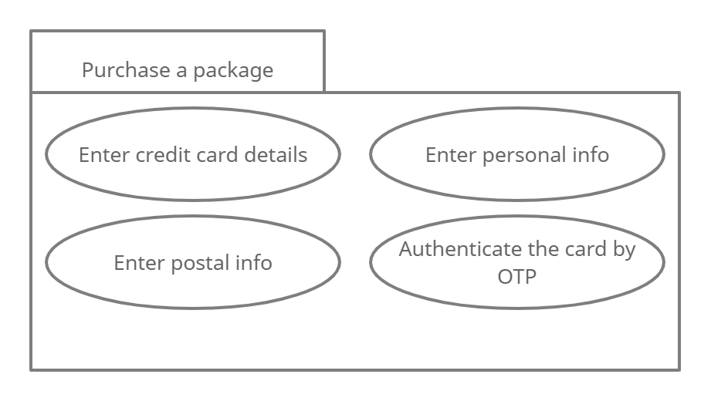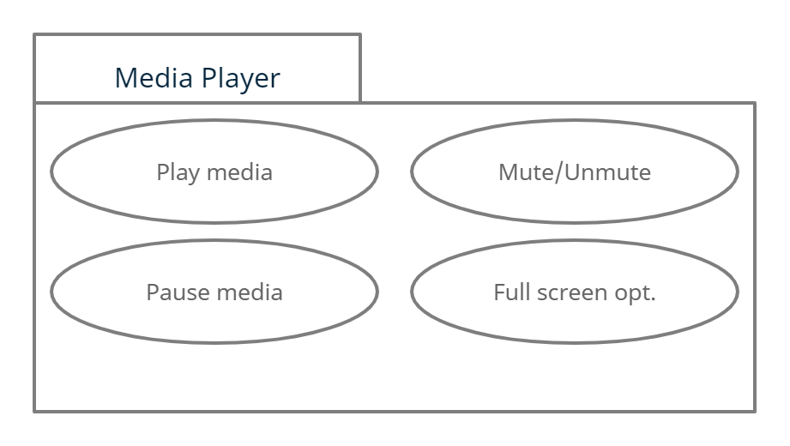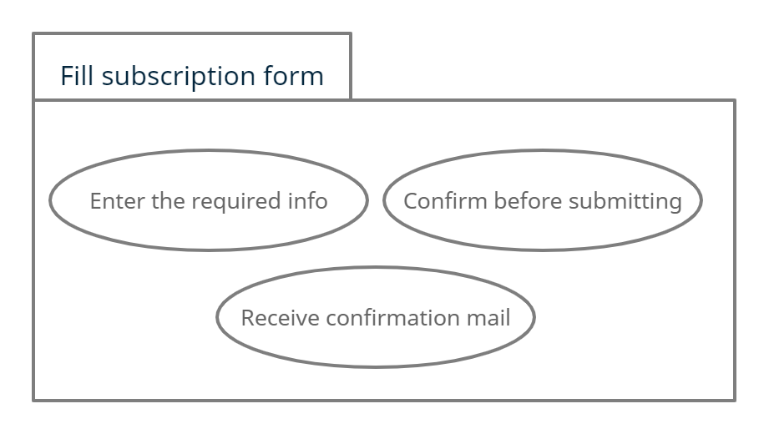

**Activity Diagram**

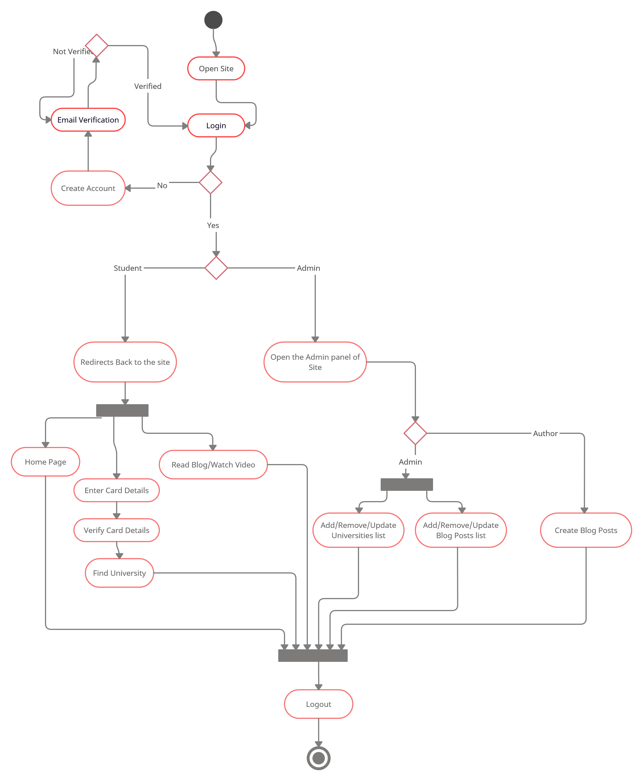

**Activity Diagram with Swim Lane**

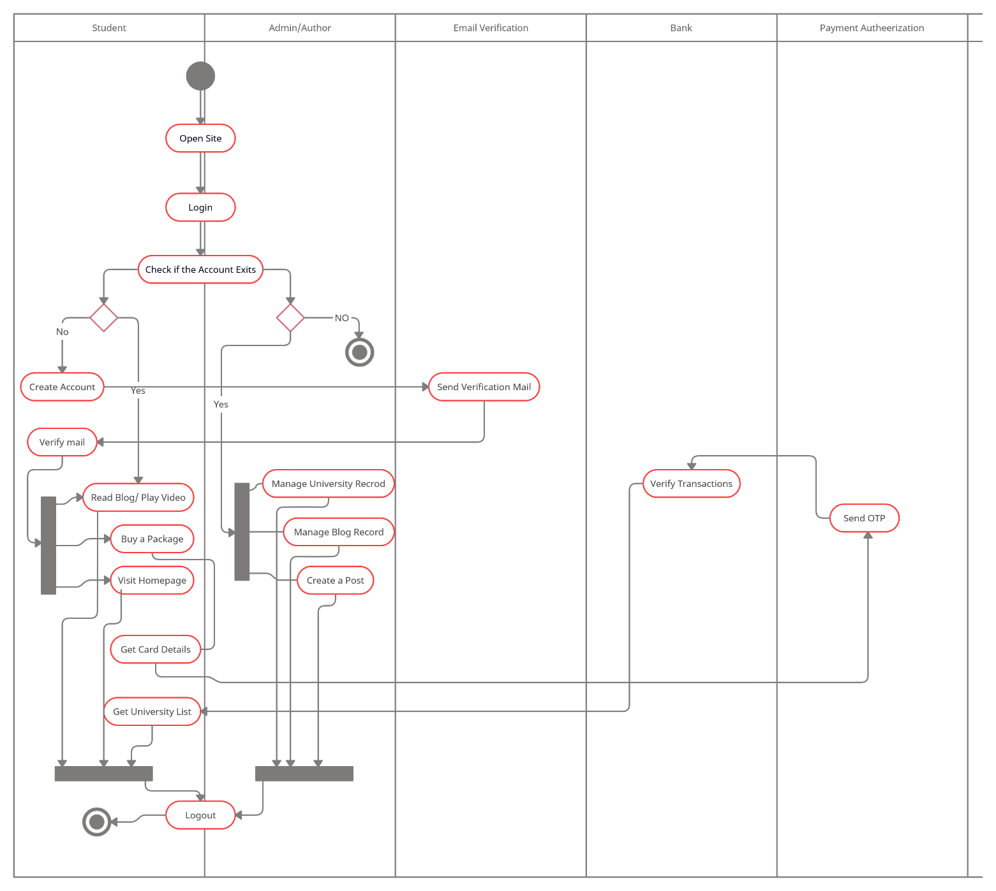

**Business Level Use case diagram**

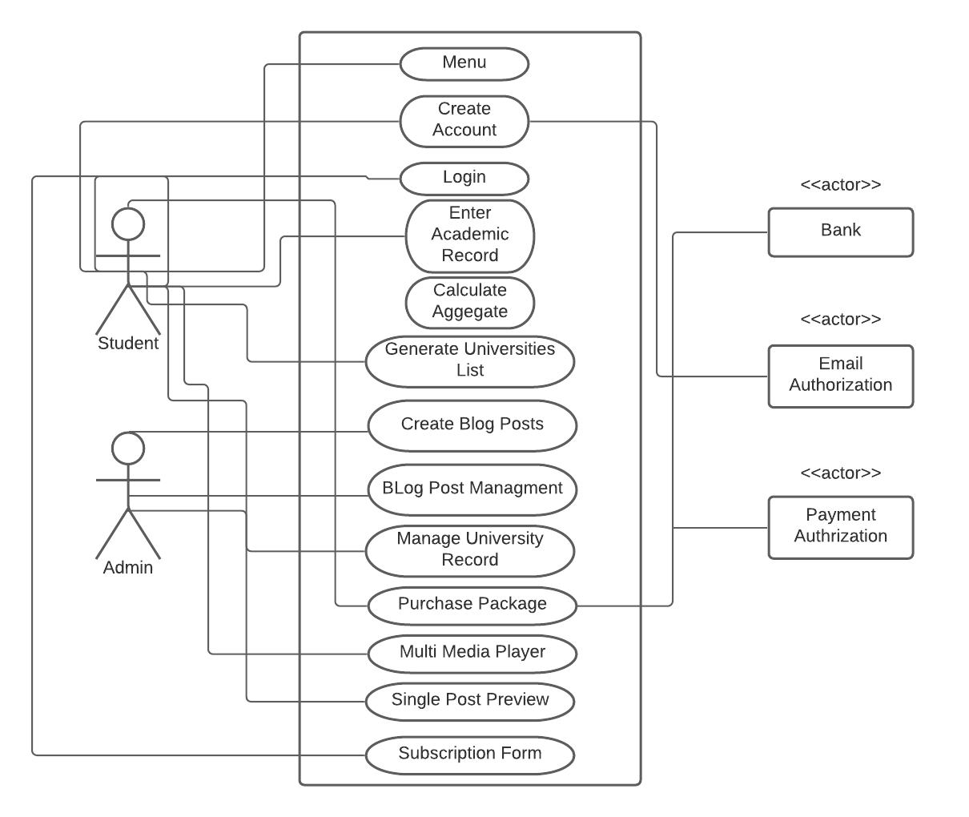

**Analysis Level Use case diagram**

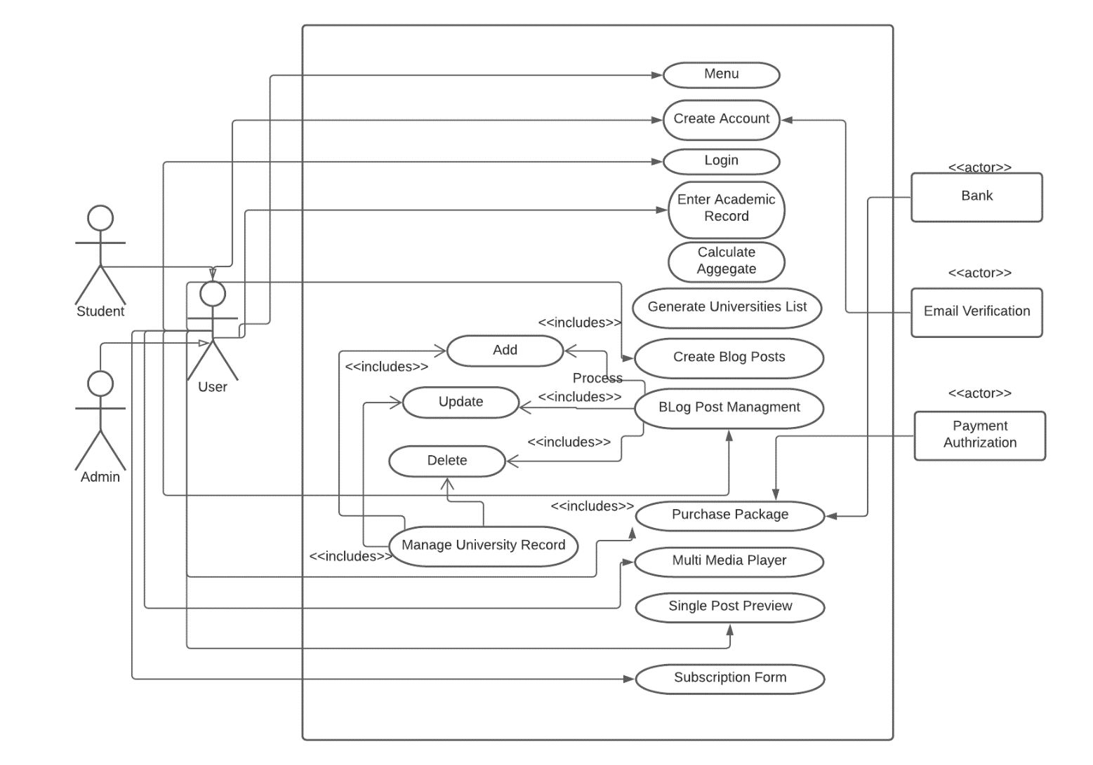

**State Chart Diagram**

***Generating University List:***

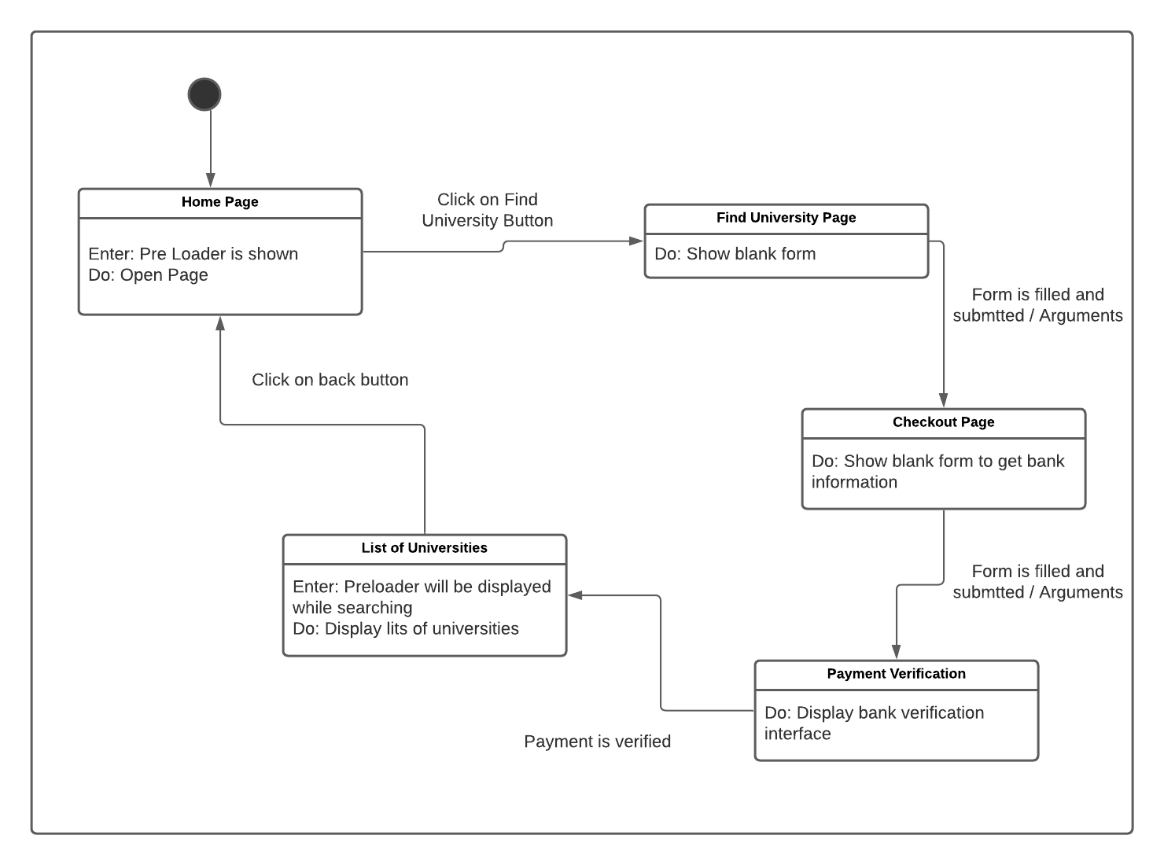

***Managing Blog Posts:*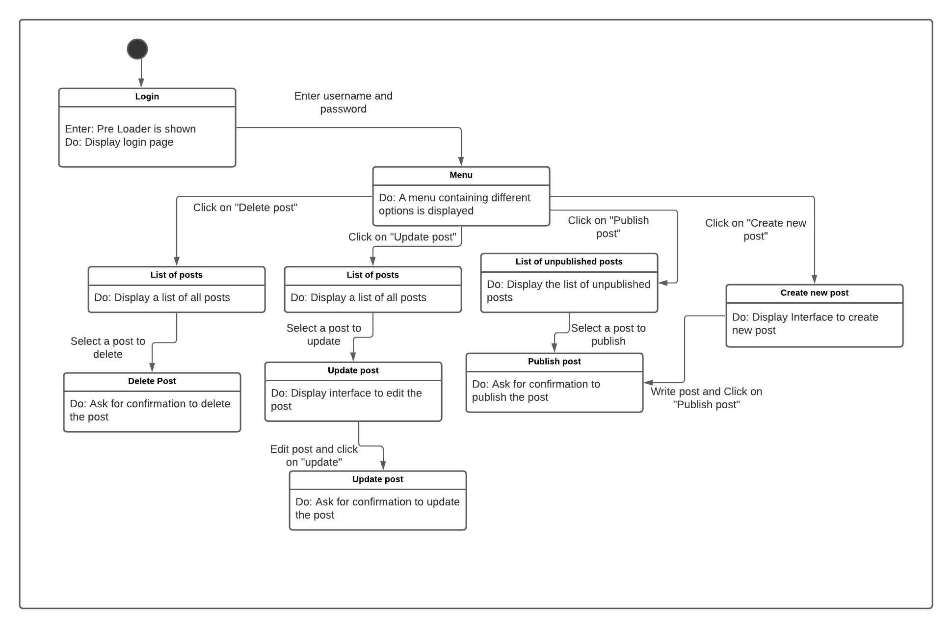**

***Managing University Record:***

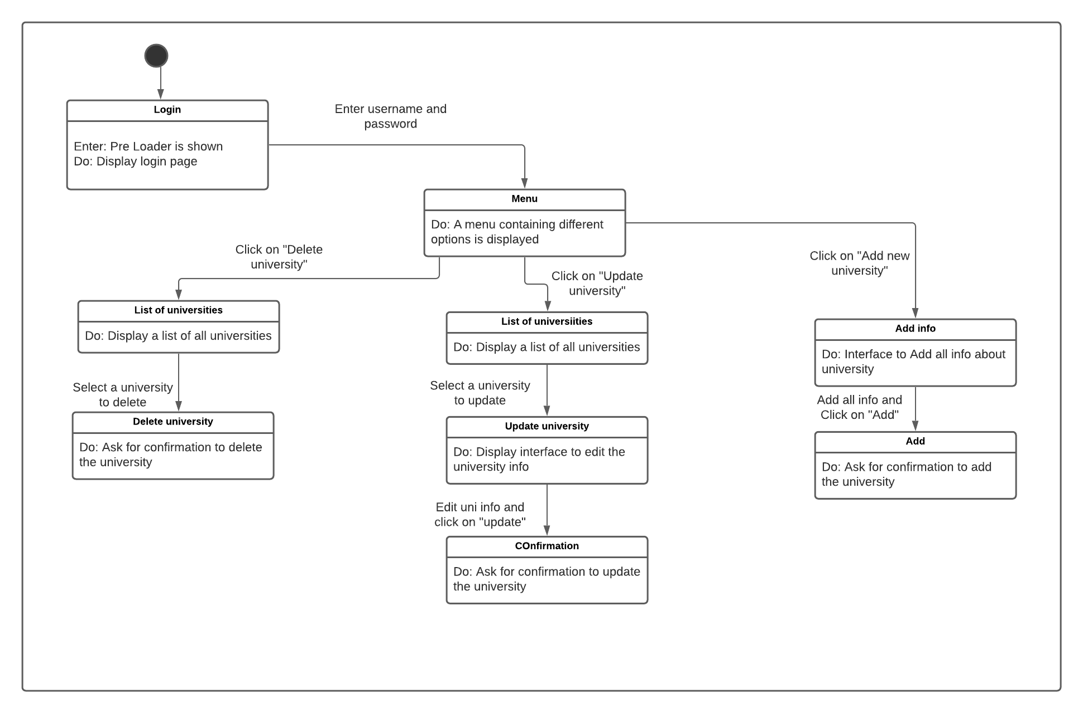

**____________________________________________**

**Glossary:**

* G 4 Guidance
  + G 4 Guidance is a project to help students in choosing Universities.
* Aggregate
  + Aggregate is a single merit number that is formed after putting all marks in some formula.
* Checkout page
  + Checkout page is a compulsory part of every site that provide some paid online services, in this page user have to enter his card details and confirm payment.
* Video progress slider
  + Video Progress Slider is a slider that indicates the progress of video, also we can forward or rewind video using it.
* Media player
  + Media Player is a platform where we can watch our video or listen to audio, also you can use pause, play or rewind options.
* Admin
  + Admin is a person that can added, remove or manage all the data of our website.
* Subscription form
  + Subscription form is simple form used to collect email for marketing purposes.
* Bot
  + Bot is program that performs cycle of task for which we have trained it like a chat bot is used to answer with humans or to answer their queries.
* Captcha
  + Captcha is a tool that is used for human verification to avoid bot attacks on our application.
* OTP
  + One Time Password is used for verification purposes i.e. an OTP is sent by bank to verify payment.
* Quick links
  + Quick links are the most commonly used links of a website, these links are placed at main portions of a website like footer.
* Color blinds
  + Color blindness is when a normal person is unable to see some original colors i.e. a red apple appears grey to a color blind person.
* Browser Timeout
  + Browser timeout is the time after which browser will not further tends to load page rather it shows an error message. Different browsers have different browser timeout in range of minutes.
* Compile time
  + Compile time is the time taken by some lines of code to change from some high level language to a machine executable form.
* Runtime
  + Runtime is the time taken by a program to be fully executed.
* Hosting / Azure hosting
  + Hosting is a platform where we need to put all our website site to make them available over internet.
  + Azure is platform that provides different services, hosting is one of these services.
* Open source
  + Open Source means any code that is freely and publically available for changing or use.
* Libraries
  + Library is a class or collection of classes that are implemented and provided by the founder of language, we just need to include these classes use them without implementing.
* GitHub
  + GitHub is an online open Source Platform provided py Microsoft. It is a platform where different people can open source their code and anyone around the globe can use them.
* Frontend
  + Frontend is the looks and feel of some applications.
* Backend
  + Backend is the part of application that is not accessible by users rather it is used to process, sort and manage data.
* FBR
  + Federal Board of Revenue is a Government institute that makes law about tax collections.

**-----------------------------------------**

**Deliverable No.2**

**DOMAIN MODEL**

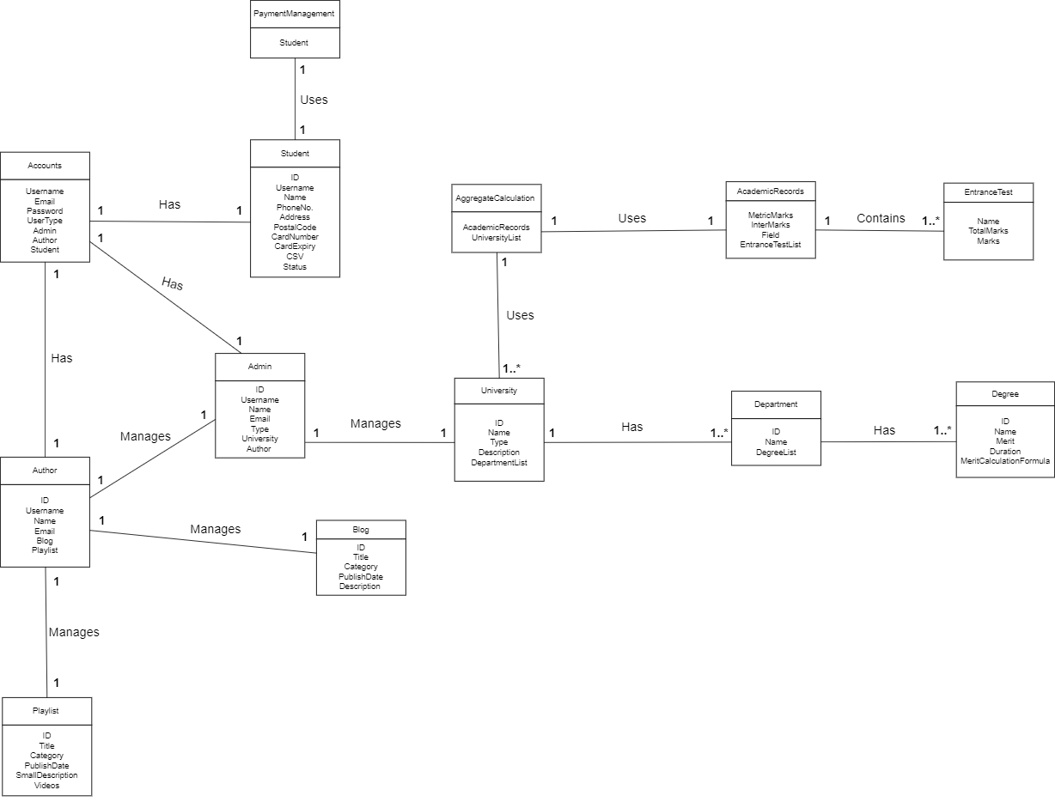

**SYSTEM SEQUENCE DIAGRAMS**

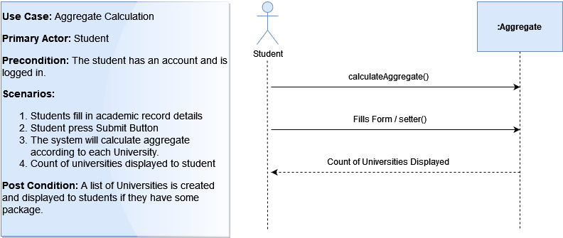

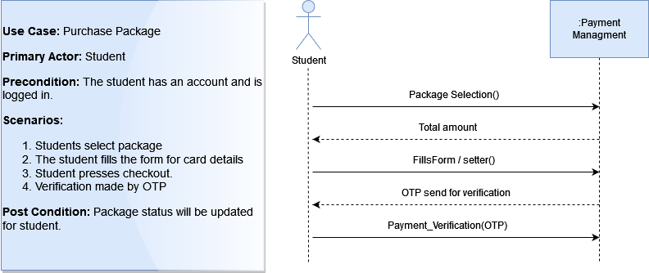

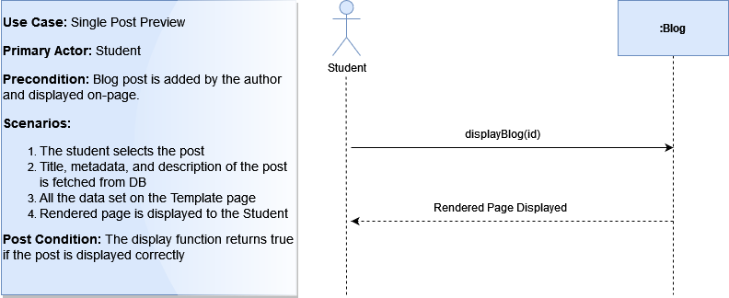

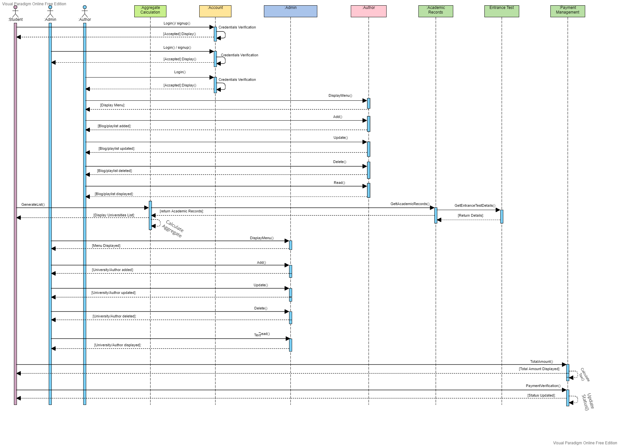

**Sequence Diagram Diagram**

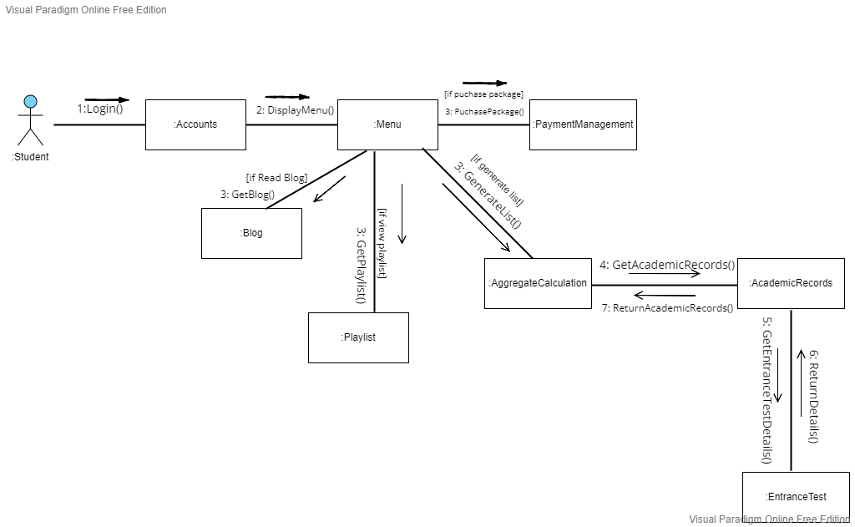**COLLABORATION DIAGRAMS**

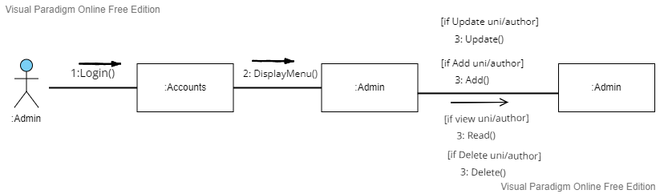

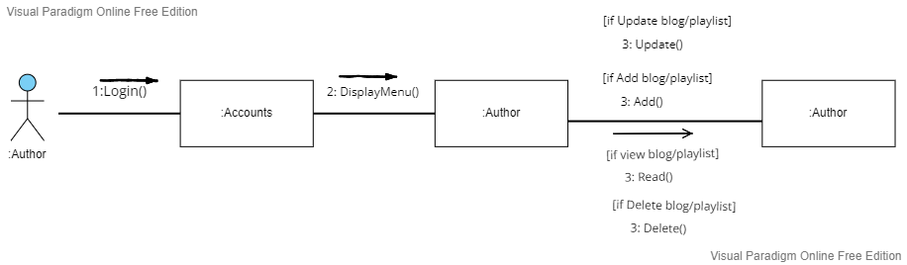

**DESIGN CLASS DIAGRAM**

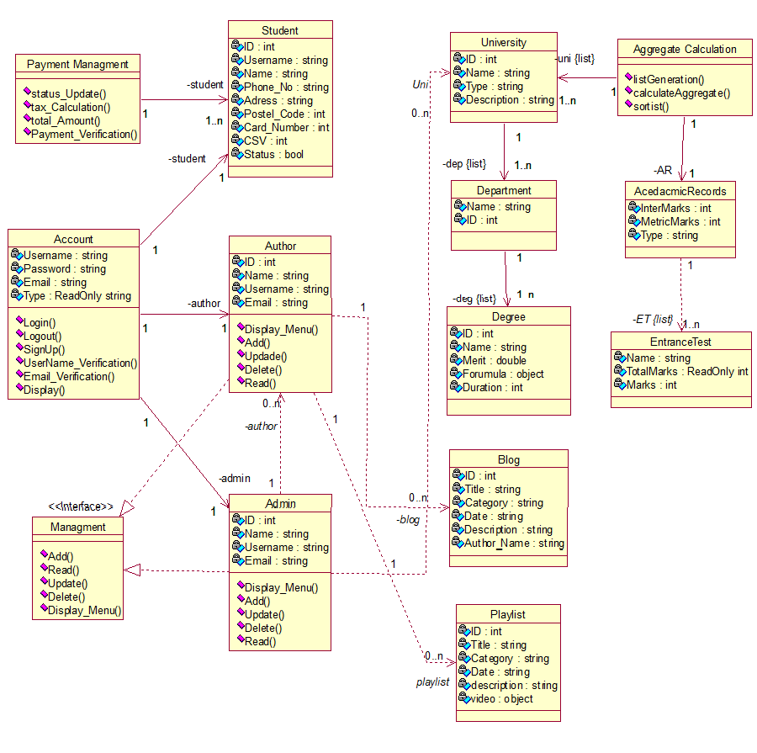

**MODEL VIEW CONTROLLER**

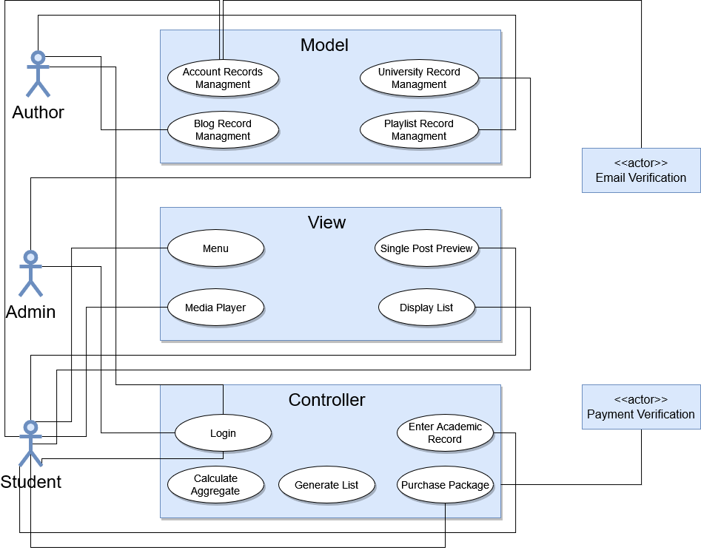

**USE CASE CONTRACTS**

|  |
| --- |
| **Contract#01**  **(Architecturally Significant)**  **Operation:**  displayBlog(id)  **Cross Reference:**  **Use Case:** Single Post Preview  **Preconditions:**  Post page is accessed and clicked on a blog post  **Post conditions:**   1. Post is searched by id 2. Title of the post is set in template 3. Metadata of post is set in template 4. Description is set in template 5. Post is rendered and show to the user |

|  |
| --- |
| **Contract#02**  **(Business Significant)**  **Operation:**  StatusUpdate()  **Cross Reference:**  **Use Case:** Purchase Package  **Preconditions:**  Student have bought some package  **Post conditions:**   1. Student.id will be set TRUE 2. Student can preview the list of Universities 3. Student will not be asked for payment until his/her package is expired. |

|  |
| --- |
| **Contract#03**  **(Risk Significant)**  **Operation:**  Payment_Verification(OTP)  **Cross Reference:**  **Use Case:** Purchase Package  **Preconditions:**  Card details are filled and proceed to checkout is pressed  **Post conditions:**   1. An is OTP to send to the card holder 2. An OTP is also stored in Payment_Verification(OTP) 3. If both entered and function’s OTP is correct then UpdateStatus() function is called. 4. Payment is completed and student information is updated. |

**PROTOTYPES**

